Steven Mathias
8/1/2026
CS 499 Capstone
Module Five
Enhancement Three: Narrative
Enhancement three continued progress on the Course Planner C++ program that was created for CS 300 Analysis and Design. For the category of databases, I chose to implement a fully functional login method that connects to an SQLite database to authenticate a user to determine if they are an admin or a standard user. If authenticated as an admin, additional CRUD (Create, Read, Update, Delete) features become accessible.
Adding these enhancements, I demonstrate the ability to create a complex structure for authenticating a user that requires different functionality based on role. In addition to verifying and authenticating credentials, I also added security methods for preventing SQL injection. The prepared statement ensures that an SQL injection is not passed into the program and read as a command. The SQLite database integration takes the simple program that only loads and displays data from a file, into a much more complex system, reflecting successful software engineering methods and practices, as well as the course outcome for developing a security mindset that anticipates adversarial exploits to expose and prevent potential vulnerabilities.
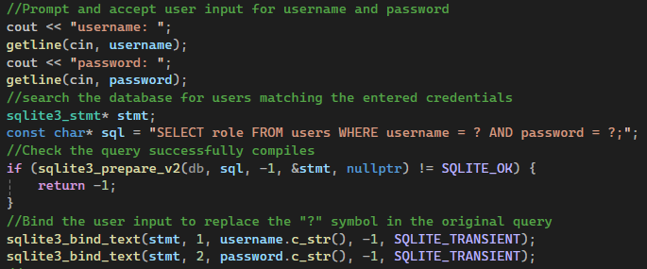
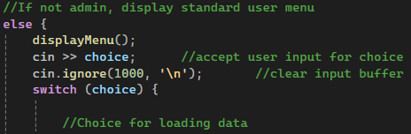
While the database requirement was satisfied with the SQLite database integration along with the login authentication, I wanted to push myself to see if I could complete the additional element of CRUD for an admin user. This ended up being the most difficult aspect as the main method required a lot of tweaking and trial and error to get fully functional. There were many small details that had to be corrected for the flow between the while loops for admins versus a standard user. I was able to get it semi-functional pretty quickly, but the specific positioning of “cin >> choice”, and return values required a lot of testing, going through the program with each option for both user and admin to ensure each option worked as it should, as well as returned the appropriate menu or response.
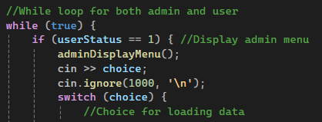

The source code below reflects part of the main method that creates a table to format the role, username, and password, while allowing an admin to add an entirely new course entry, update existing values, or delete an entry. Additionally, I added mock credentials for testing functions under each user role.
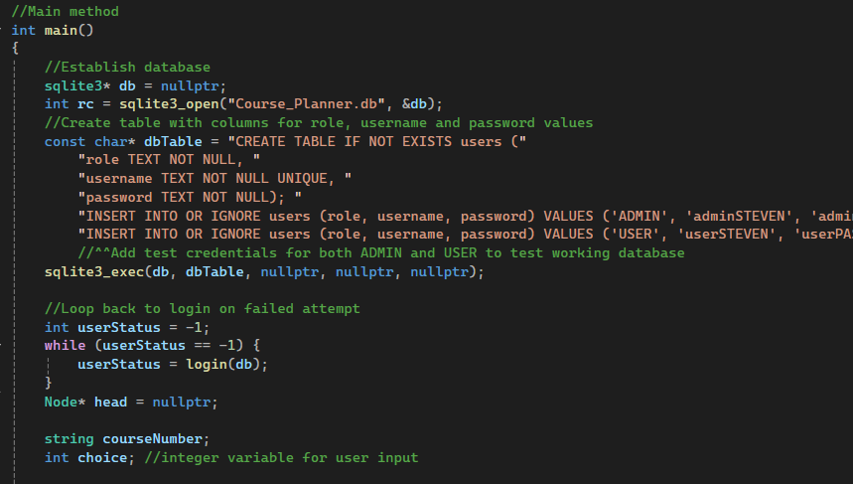
As this enhancement completes the three major components, I believe that I have successfully met the course outcomes, combining software engineering principles for code architecture and programming design, secure coding, data structures and finally database integration. The course planner program satisfies the course outcome of building collaborative environments as demonstrated by the role authentication and CRUD features. Across my three enhancements, I demonstrate a well-rounded and logical approach to successfully completing programming projects across an array of project types.

